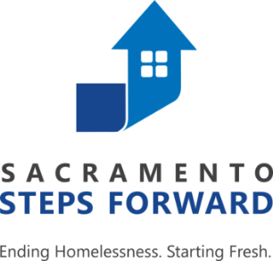

CES Committee Meeting
Thursday, August 2, 2018
3:00 PM – 4:30 PM
Nonprofit Innovation Center, 1331 Garden Highway, Sacramento, CA 95833
Meeting Room: VCR (2nd Floor)

Agenda Item | Presenter | Time
I. Welcome & Introductions | John Foley & Jenn Fleming, Co-Chairs | 3:00 PM  (5 min)
II. CES Committee 6-Month Work Plan  - CES Staff Priorities  - Dynamic Prioritization  - Progressive Engagement  - Housing Conferencing  - Referral Outcomes  - System Mapping  - Additional Topics & Priorities from CES Members | Nick Lee, Michele Watts, & Tristina Stewart, SSF Staff  And  All Members | 3:05 PM  (45 min)
III. Updates  - HUD TA Request  - Quarterly CES Stakeholders Meeting | Nick Lee, Michele Watts, & Tristina Stewart | 3:50 PM  (15 min)
IV. Adjourn  - Next Meeting: September 6, 2018 | John Foley & Jenn Fleming | 4:05 PM

